INTRODUCTION

1.1 OVERVIEW

The project aim is to provide real time knowledge for all thid student who have basic knowledge of salersforce and looking looking real time project.

1.2 PURPOSE

An event management is the process of creating and maintaining an event. This process spans from the very beginning of planning all the way to post event strategy.

2.1 EMPATHY MAP

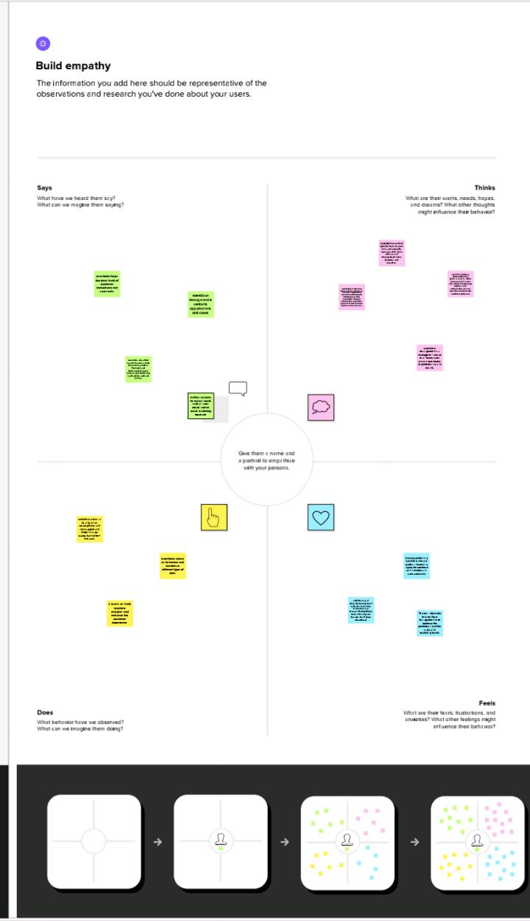

2.2 IDEATION AND BRAIN STORMING MAP

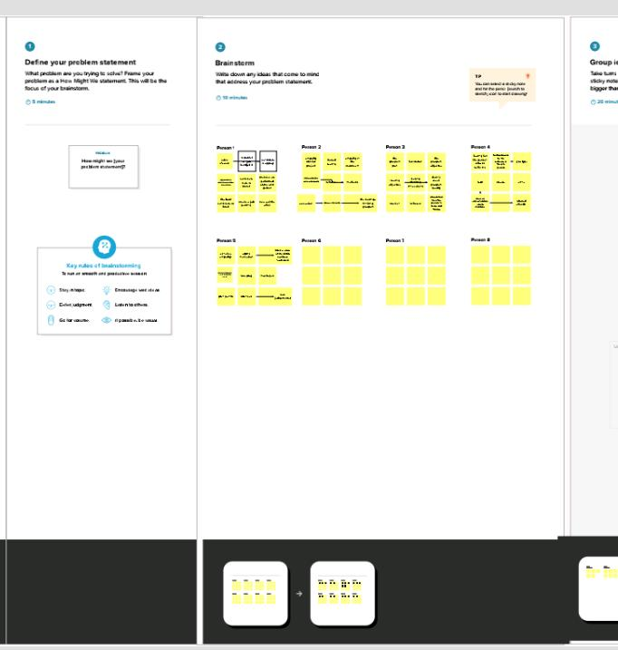

RESULT

3.1 data model

|  |  |
| --- | --- |
| Object name | Fields in the object |
| Obj1 | |  |  | | --- | --- | | Field label | Data type | | Mobile | Contact number | | text | Pass port | |
| Obj2 | |  |  | | --- | --- | | Field label | Data type | | Email | number | | email | text | |

3.2 activity and screenshot

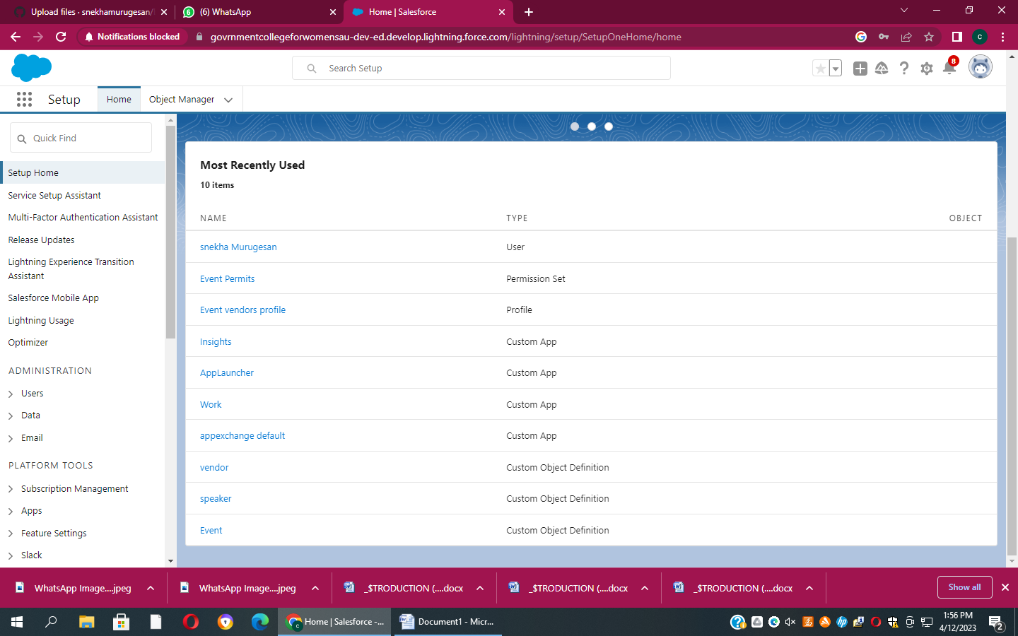

Advantages & disadvantages

ALL different branches of planning go into the event management.

Applications

In event management you could not be process in the creating a conference.

CONCLUSION

Any event that requires considerable planning and exclusion is the event management.

FUTURE SCOPE

This process spans from the very begging of planning all the way to post event strategy.